Session 7 WORK EDUCATION 23rd March

Introduction to OH&S
- Student OH&S sheet indicates what needs to be completed. This can be found under teams Session 7 (and 8).
- Worksheet has two links for videos – please watch as a class. Links below:
Work safe videos - https://www.youtube.com/watch?v=EcIfaNn1JoY

https://online.clickview.com.au/libraries/series/9551990/how-to-succeed-at-work-experience/videos/16237850/workplace-health-and-safety

- Please also show the following very short videos using this link – it’s a teacher resource so I have not added to their task sheet
https://www.worksafe.vic.gov.au/worksafe-101-high-schools-program-resources
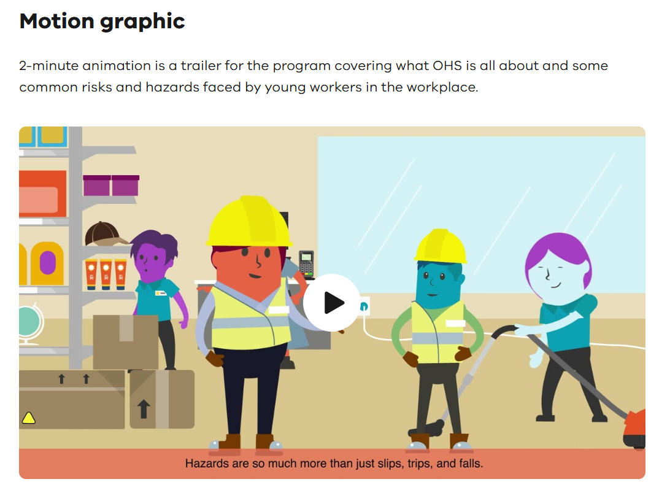
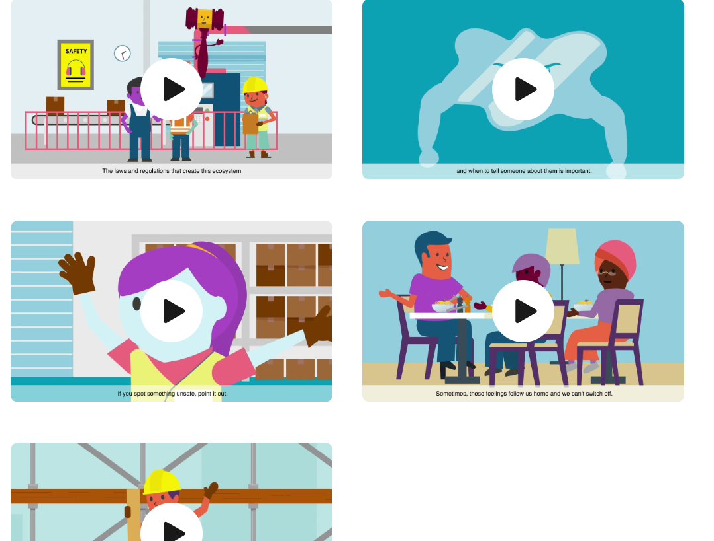

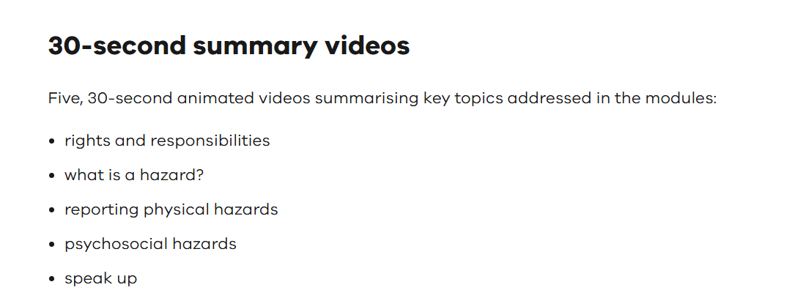
These are:

TASK 1
Once videos are shown, they are to complete a fun hazard challenge (game)
before commencing the reading needed for the completion of the General OH&S module. They will be completing the General Module (learning Task) next week – 30th March
Spot the hazard https://spotthehazardsworksafebc.com/

TASK 2
Students are now ready to start their reading in preparation for the General module. Go through task sheet as a group and read WHAT IS SAFE @ WORK?
They are then to log onto the website indicated on their handout www.education.vic.gov.au/safe@work/modules/industry/index.asp
and start reading the required info – all under specific headlines.
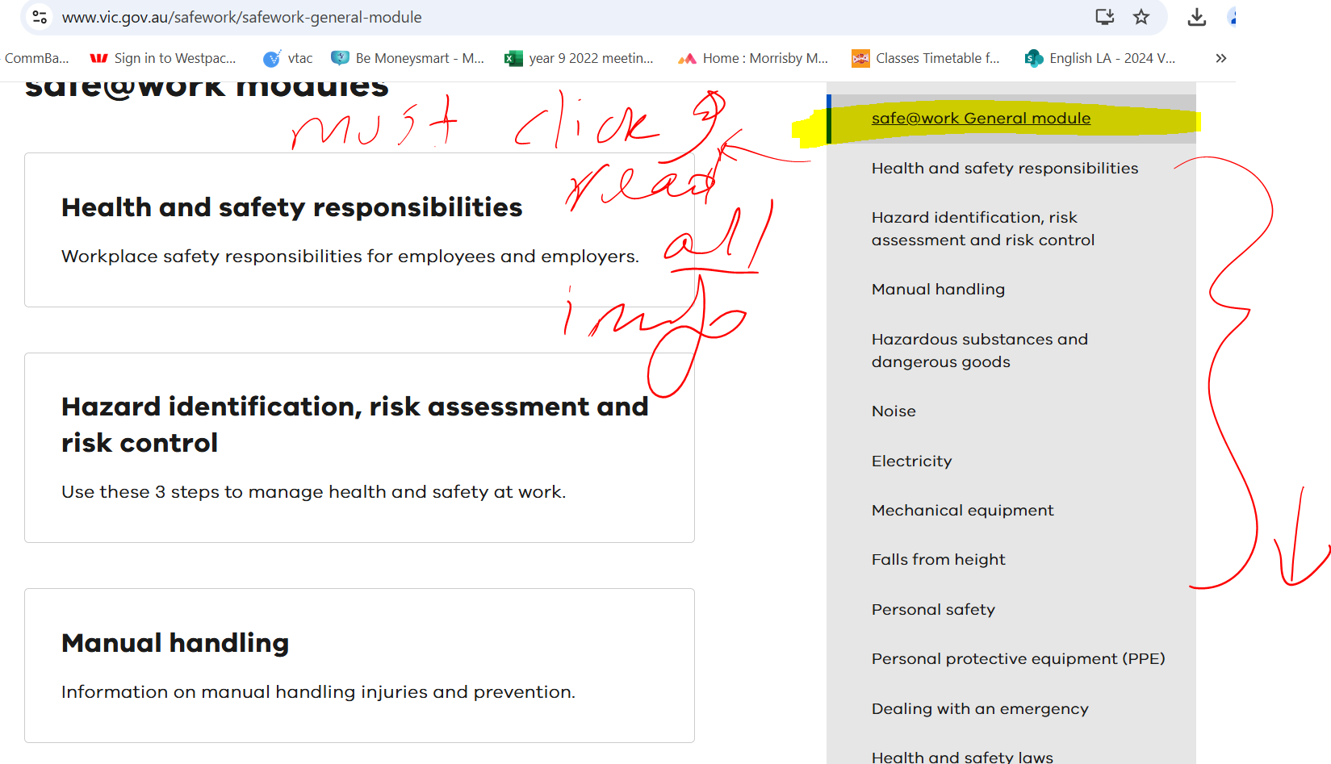

Information about completing the modules can be found in teams.
*****If students are not engaged in the reading during class (after they complete Task 1- quiz) they can read the required information at home and use the rest of the period to complete OH&S activities as an intro under our career website/career tools/Workplace Health and Safety
